Interview Preparation for Sr. Manager CDM Role at Pliant Therapeutics

Research the Company and Role
- Pliant Therapeutics: Focus on developing novel therapeutics for fibrotic diseases.
- Company Values: Commitment to innovative science and addressing unmet medical needs.
- Therapeutic Approach: Focus on integrin biology and TGF-β modulation.
- Location: South San Francisco; recent recipient of "Best Place to Work" award.
- Key Links:
  - Briana Ault-Davis LinkedIn Profile
  - Pliant Therapeutics LinkedIn
  - Pliant Therapeutics Website
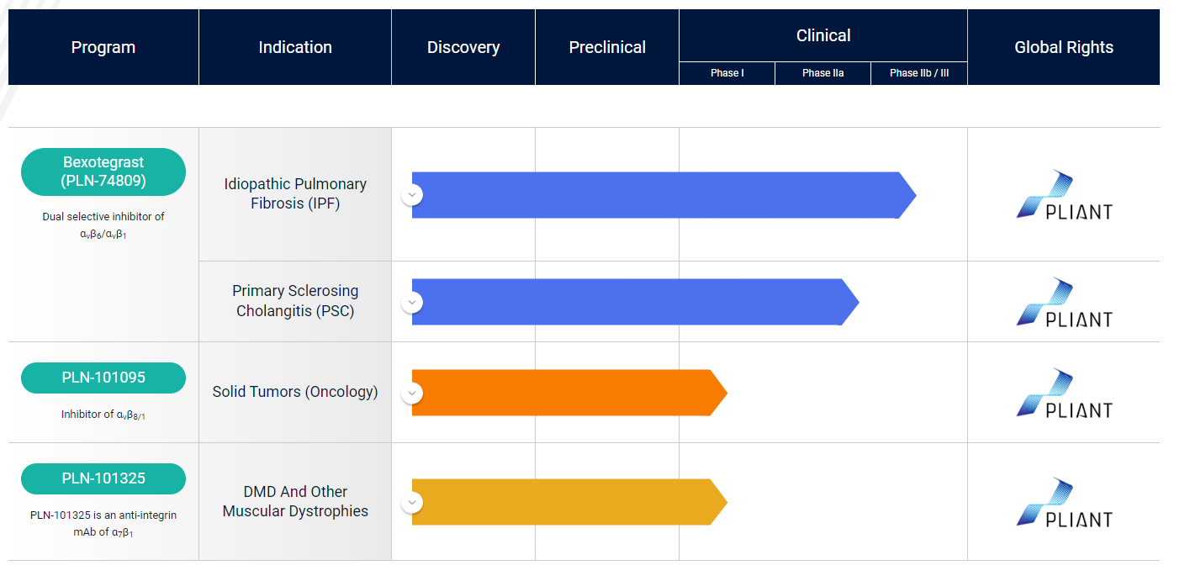
- Action Steps:
  - Review the company's recent news, products, services, and mission/values.
  - Study the job description in detail and align your experience with the key requirements.
  - Prepare 2-3 questions about the role, team, and company to ask during the interview.

Review Your Experience
- Experience: 21+ years in Clinical Data Management (CDM) across all study phases.
- CDM Study Lead: Experience leading Phase I-IV trials.
- Oncology Expertise: 17 years of experience in oncology trials.
- Leadership: Experience managing CROs, vendors, and internal teams.
- Technical Skills: Proficient with EDC systems like Medidata Rave, Veeva CDMS, etc.

Prepare STAR Stories
- Leading EDC Modifications: Implementing changes at C4 Therapeutics.
- Vendor Data Reconciliation: Improving processes at Ideaya Biosciences.
- Managing Study Amendments: Handling complex amendments across teams at Spero Therapeutics.
- New Data Review Approaches: Implementing new methods at Insight Clinical Consulting.
- Mentoring and Training: Mentoring CRO and in-house DM staff at multiple companies.
- Resolving Critical Data Issues: Specific examples from past roles, such as resolving data issues close to database lock.
- Streamlining CDM Processes: Examples include SAE reconciliation and LNR management.

Highlight Your Strengths
- Therapeutic Experience: Extensive experience in oncology and rare diseases.
- Technical Proficiency: Strong technical skills across multiple EDC systems.
- In-House and Outsourced CDM Models: Experience with both models.
- Process Improvements: Proven track record of implementing best practices.
- Leadership Skills: Experience managing teams and collaborating cross-functionally.
- Adaptability: Ability to work across different company cultures and trial types.

Prepare for Common CDM Interview Questions
- How do you ensure data quality and integrity throughout a clinical trial?
- Describe your approach to CRO and vendor oversight.
- How do you handle conflicting priorities or tight timelines?
- What strategies do you use for effective cross-functional collaboration?
- How do you stay current with industry trends and regulatory requirements in CDM?
- Describe a challenging data management issue you encountered and how you resolved it.
- How do you approach training and mentoring team members?
- What process improvements have you implemented in previous roles?
- How do you ensure consistency in data collection across multiple sites?
- Describe your experience with risk-based monitoring approaches.

Questions to Ask the Interviewer
- What are the unique CDM challenges in managing trials for fibrotic diseases?
- How does Pliant's CDM team collaborate with other functions to support integrin biology and TGF-β modulation research?
- What opportunities exist for implementing innovative CDM approaches in Pliant's clinical trials?
- How does Pliant's company culture support cross-functional collaboration in clinical development?
- What are the key priorities for this role in supporting Pliant's late-stage clinical programs?

Additional Tips
- Review any publicly available information on Pliant’s clinical trial designs for fibrotic diseases.
- Be prepared to discuss your experience with relevant therapeutic areas, especially those related to fibrosis.
- Highlight any experience with EDC systems specifically used in fibrosis or rare disease trials.
- Be ready to discuss your approach to managing CDM for complex, potentially long-term trials typical in fibrotic disease research.
- Prepare examples of how you’ve applied evolving CDM best practices to challenging therapeutic areas.

Closing the Interview
- Reiterate Interest: Emphasize your interest in contributing to Pliant’s mission of addressing unmet needs in fibrotic diseases.
- Summarize Experience: Align your extensive CDM experience, especially in complex therapeutic areas, with Pliant’s needs.
- Emphasize Adaptability: Highlight your ability to quickly adapt and bring best practices from diverse trial experiences to support Pliant’s growing clinical programs.

